Cleaning:
- Clean the helmet (and any accessories) using only water, mild soap and a soft, clean cloth, and let it air dry at room temperature.
- The internal padding can be removed and washed by hand in cold water or in the washing machine (max. 30°C - 85° F).
  - Air dry only, spare liner may be useful to rotate.
- Do not use paints, solvents, chemicals, adhesives, gasoline or like substances on this helmet, because doing so can reduce the protection from impact and penetration.
Storage:
- When not in use, the helmet should be stored away from direct sunlight and sources of heat.
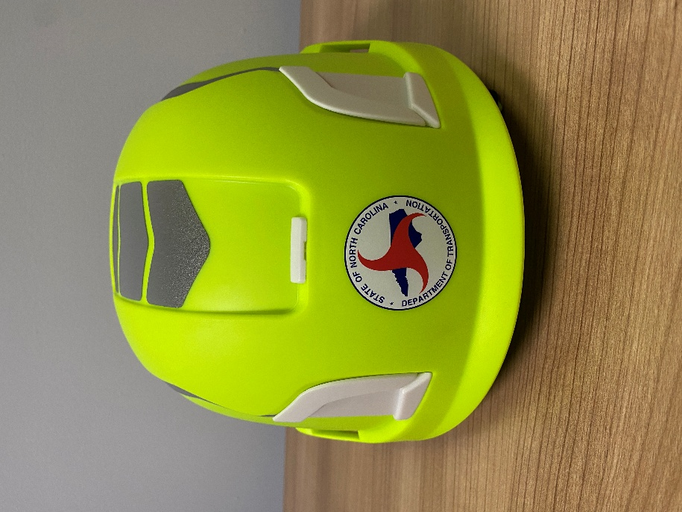
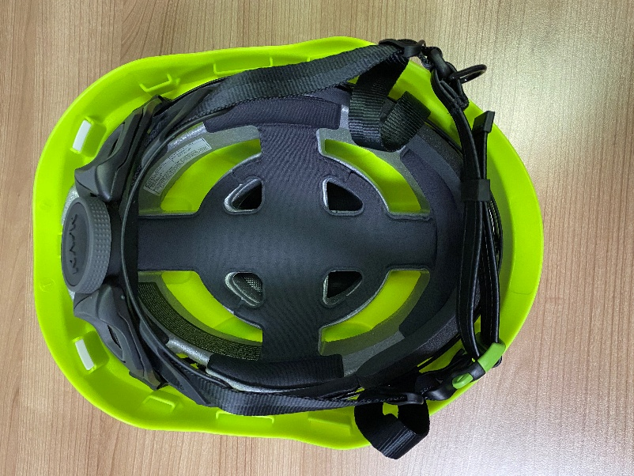
  - Recommend putting it in the original package storage bag. Keep off truck dashboards and headrests.
NCDOT KASK Zenith X2 – Removable Liner
NCDOT KASK Zenith X2



